**Resume’ Writing**

Meaning:

Resume, (English) to restart

**Resume’ (French) – to summarise**

**CV-(Latin) -The story of your life**

**Font Type:**

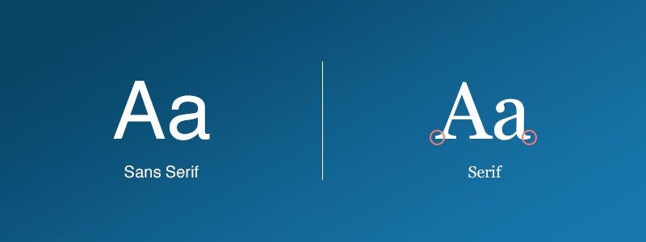

1. **Seriff-** Times New Roman

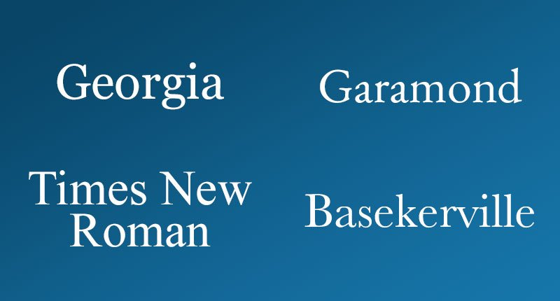Georgia

1. Sans-seriff- Verdana, Helvetica, Arial

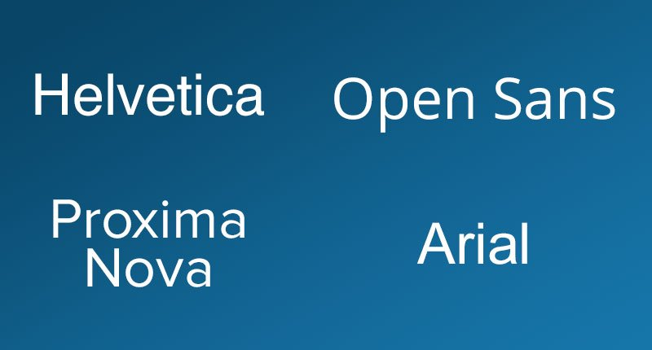

**Serif fonts:**

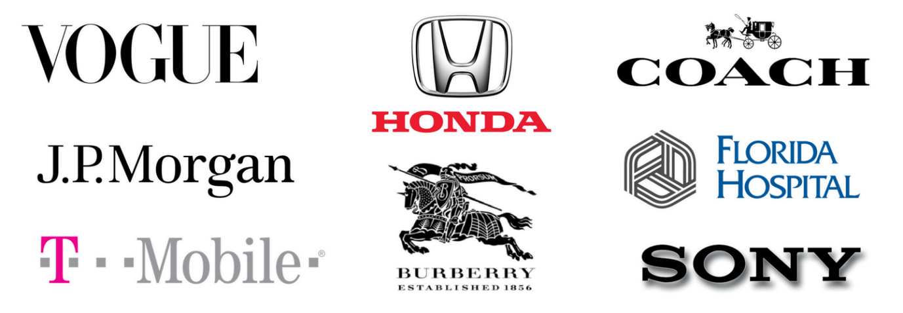

serif fonts [give people a feeling of elegance, confidence, and trustworthy.](https://www.crazyegg.com/blog/psychology-of-fonts-infographic/)

**Sans Serif fonts:**



Sans serif fonts give off a feeling of being casual, informal, friendly, and very approachable. Companies who want their brands to appear more youthful and relatable tend to use sans serif fonts.

**1. Contact details**

**A.**

**Hardik Pandya**

102, ABC Society, Pune-20

98567 23456

hardik.pandya@gmail.com

**B.**

**Hardik Pandya**

102, ABC Society, Pune-20

98567 23456

hardik.pandya@gmail.com

**C.**

**Hardik Pandya**

102, ABC Society, Pune-20

98567 23456

hardik.pandya@gmail.com

**2. Objective:**

To obtain a position of a __________ which involves the skill set of _____________ .

(18-20 words / 1.5 lines)

**3. Skills:**

**C++**

**Java**

**Python**

**Organised**

**Focused**

**Punctual**

* A strong team leader
* Demonstrated excellent ability to communicate effectively
* Have negation skills with key vendors supplying…

**4. Professional Experience:**

**Organization:** XYZ Ltd., Pune

**From**: Januray 2021 to December 2021

**Designation:** Team Lead

* Presented…
* Reported…
* Compiled…
* Assessed…
* Led a team…

**5. Educational Qualifications: / Education:**

* Pursuing a PG Diploma in DAC at ACTS-CDAC, Pune
* Completed BE in IT with **85**% from XYZ University in 2021
* 12 class

**6. Projects:**

**1. Title: ___________________**

**Summary:** (Not more than 3 /4 lines) include-technology used, procedure, what you did, what were the challenges, what was the outcome

**Note:** The project was published as a research paper**.**

**2. Title: ___________________**

**7. Trainings / Certifications:**

**8. Awards/Achievements/Extracurricular Activities:**

* Published a research paper titled “___________________” in an international magazine “____________” in 2021
* Presented a research paper titled “_______________” at a national conference held in New Delhi in 2021

**9. Hobbies:** Reading non-fiction, Writing/Reading technical blogs, making vlogs, Trekking, Cycling, Playing Tennis, Running half marathons

**(Minimum 1/Maximum 2)**

**10. Languages known:** German (A1 Level) English, Marathi, Hindi

**Don’t add the following on the resume’**

Declaration

Family background

Date of birth

Height , complexion

Caste, Religion

Photographs

Passport number

Adhar number